Revision 1: Data and transmission - Student booklet
Y11 - Cambridge IGCSE Computer Science 0478 | Exam revision
Name: _______________________________ | Date: _____________

- Learn sections are your revision notes: read them carefully, then do the task straight after.
- Task 1 is a closed-book recall test - do it from memory first.
- Questions with a paper reference are real Cambridge 0478 questions. Your teacher will share the answers.
Task 1 Recall test (closed book) [12 marks]
Answer from memory. One mark each.
# | Question | Answer
1 | How many bits are in a nibble?
2 | Convert the binary number 01011010 into denary.
3 | Convert the hexadecimal number 3B into 8-bit binary.
4 | What is the largest denary number that can be stored in 8 bits (unsigned)?
5 | What is the range of denary numbers that can be stored in 8-bit two's complement?
6 | What happens to the value of a binary number when it is logically shifted left one place?
7 | Name the three parts of a data packet.
8 | Which device decides the route each packet takes across a network?
9 | What is the difference between half-duplex and full-duplex transmission?
10 | Which error detection method uses acknowledgement and timeout?
11 | Using even parity, what parity bit is added to 1011001?
12 | In asymmetric encryption, which key is used to decrypt the data?
Learn Number systems
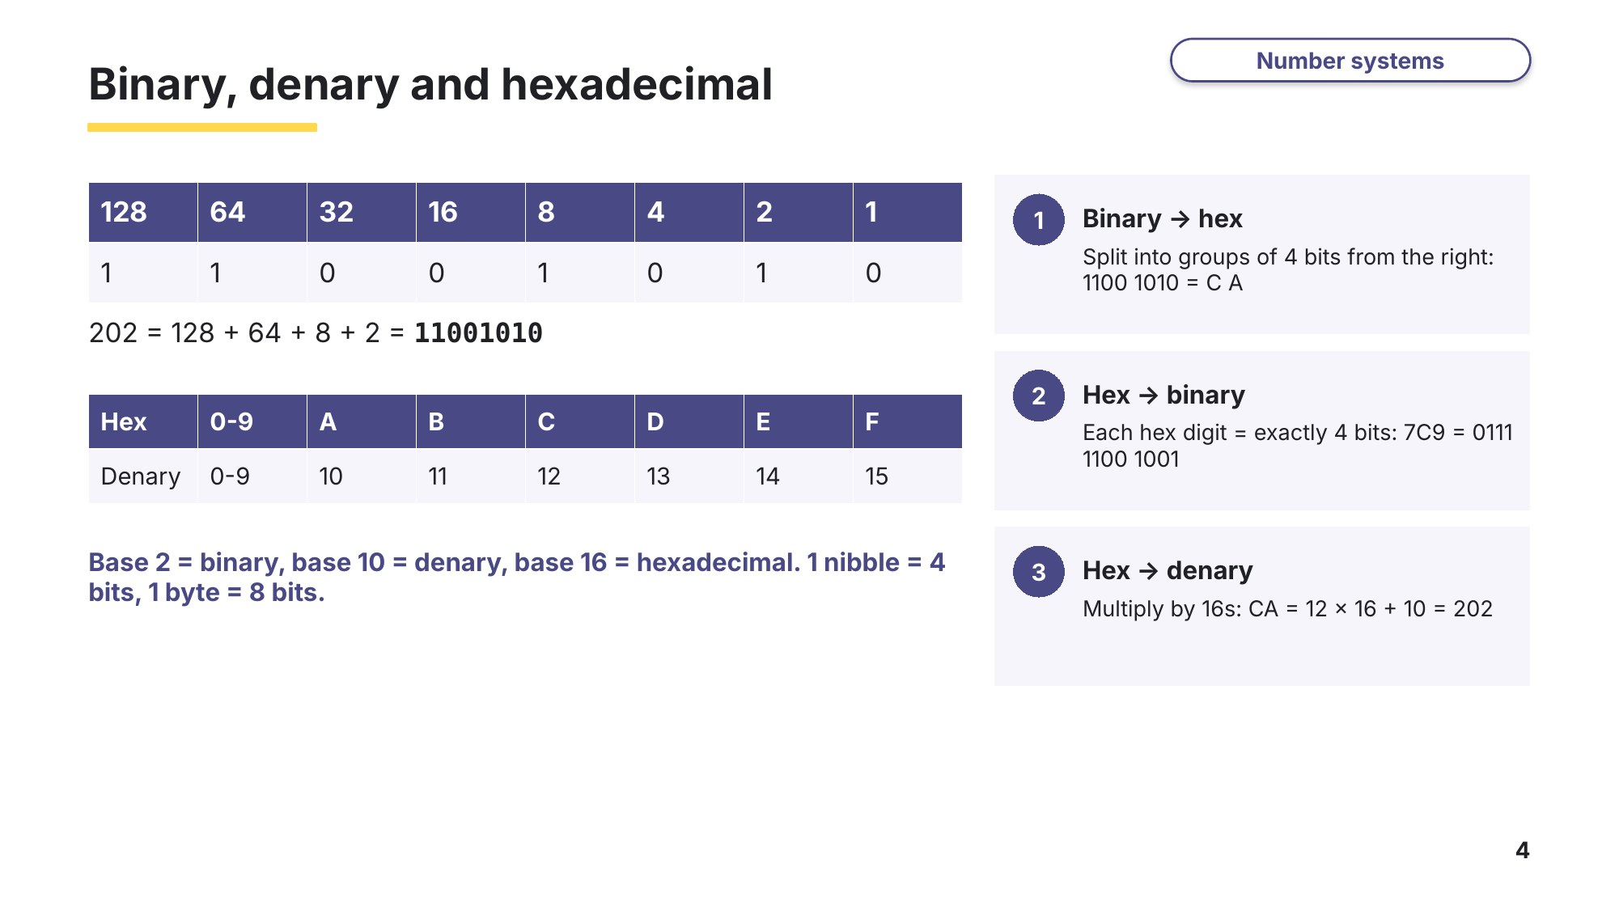
Slide 4 - Binary, denary and hexadecimal
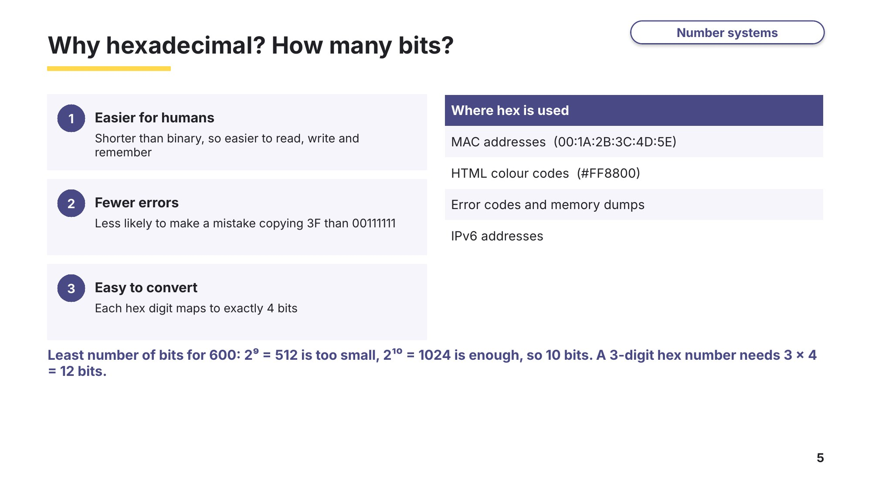
Slide 5 - Why hexadecimal? How many bits?
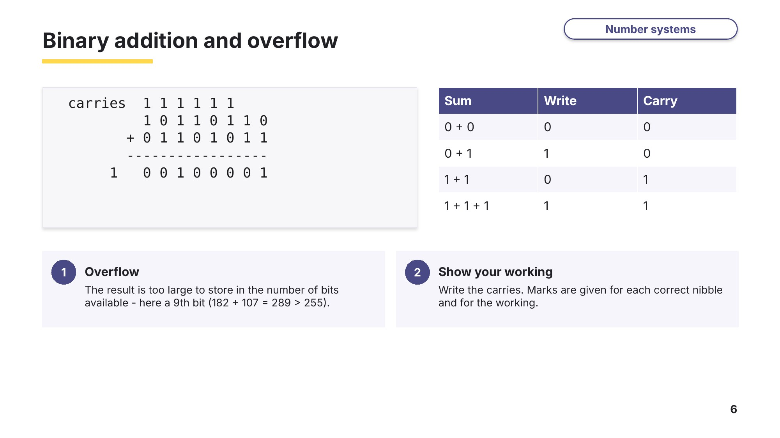
Slide 6 - Binary addition and overflow
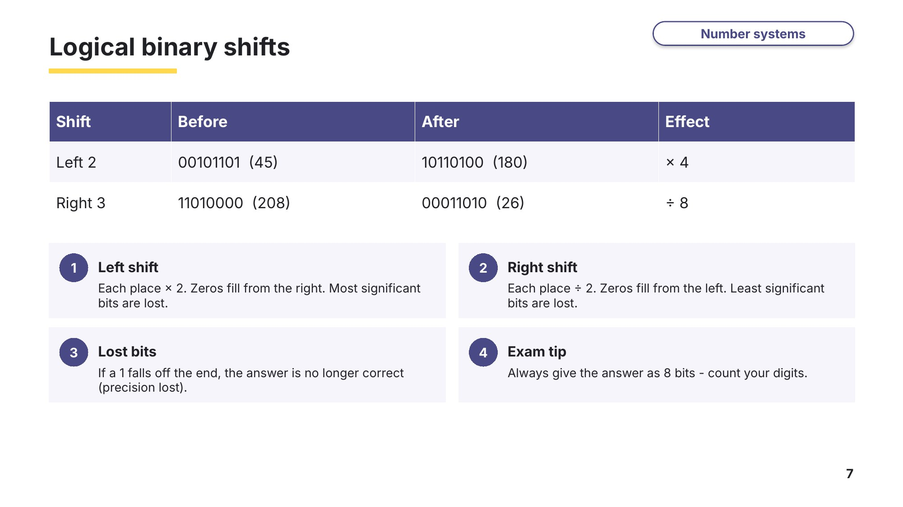
Slide 7 - Logical binary shifts
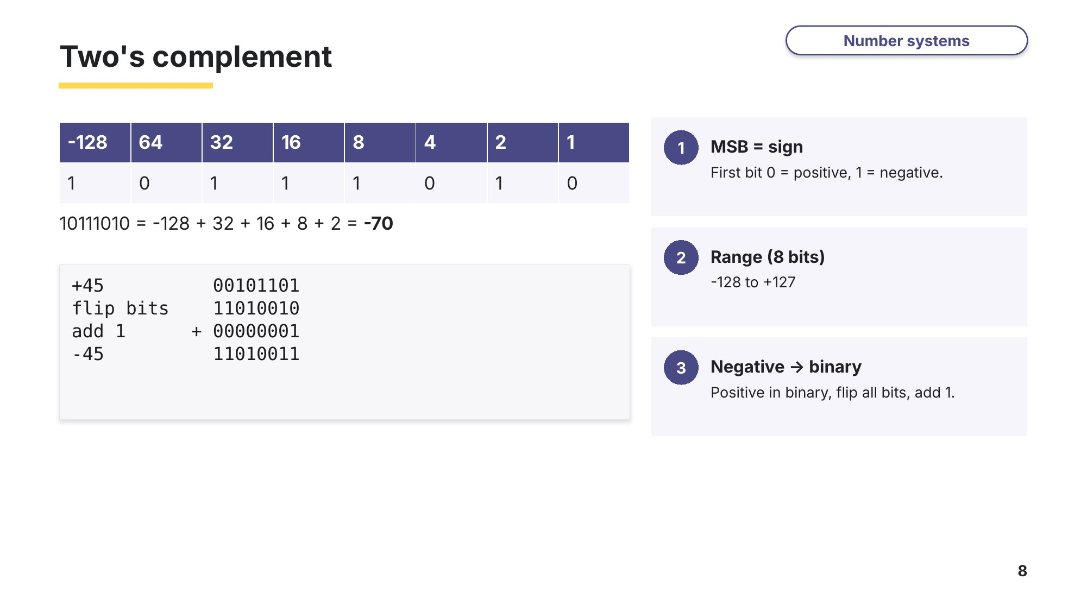
Slide 8 - Two's complement
Task 2 Number systems [27 marks]
2A Binary, hexadecimal, shifts and addition
0478/13 May/June 2023 Q1
Computers store data as binary. The binary number 10101110 is stored.
(a) Convert the binary number to denary. [1]

(b) Convert the binary number to hexadecimal. [2]

(c) A logical left shift of three places is performed on the binary number.
(i) Give the 8-bit binary number that would be stored after this logical left shift. [1]

(ii) Tick (✓) one box to show which statement is true about the impact the logical left binary shift would have on the binary number. [1]
A | The least significant bits are lost.
B | The most significant bits are lost.
C | The number has been divided by six.
D | The number stays the same.
(d) Add the two 8-bit binary numbers 11101110 and 00110001 using binary addition. Give your answer in binary. Show all your working. [4]
(e) The denary number 301 needs to be stored. Calculate the least number of bits that can be used to store the denary number 301. [1]

(f) The hexadecimal number A4D needs to be stored. Calculate the least number of bits that can be used to store the hexadecimal number A4D. [1]

2B A register and two's complement
0478/12 October/November 2023 Q2
A register stores the binary number: 1 1 1 0 0 0 1 1
(a) Give the denary number for the binary number stored in the register. [1]

(b) Give the hexadecimal number for the binary number stored in the register. [2]

(c) A logical left shift of two places is performed on the binary number stored in the register. Complete the binary register to show its contents after this logical left shift. [1]
(d) The negative denary number −99 needs to be stored in the register. Complete the register to show the binary number that would be stored, using two's complement. Show all your working. [2]
(e) The number 01001100 is added to 11100011. Add the two 8-bit binary numbers, using binary addition. Give your answer in binary. Show all your working. [4]
2C More conversions (exam-style)
(a) Convert the hexadecimal number 7C9 into a 12-bit binary number. [1]

(b) Give the 8-bit binary number after a logical right shift of three places is performed on 11011000. [1]

(c) State the effect the shift in (b) has on the denary value of the number. [1]

(d) Convert the two's complement binary integer 01011101 into denary. [1]

(e) Convert the two's complement binary integer 11100110 into denary. Show your working. [1]

(f) Give one reason why programmers often use hexadecimal instead of binary. [1]

Learn Packets and transmission
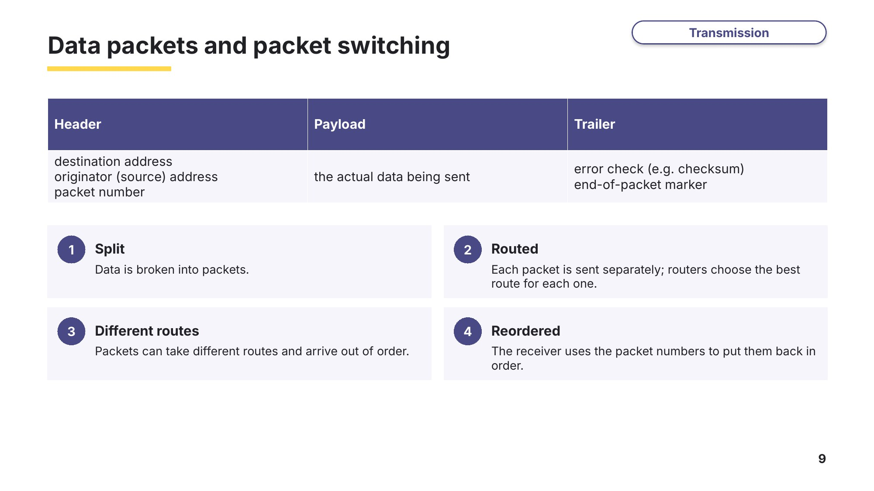
Slide 9 - Data packets and packet switching
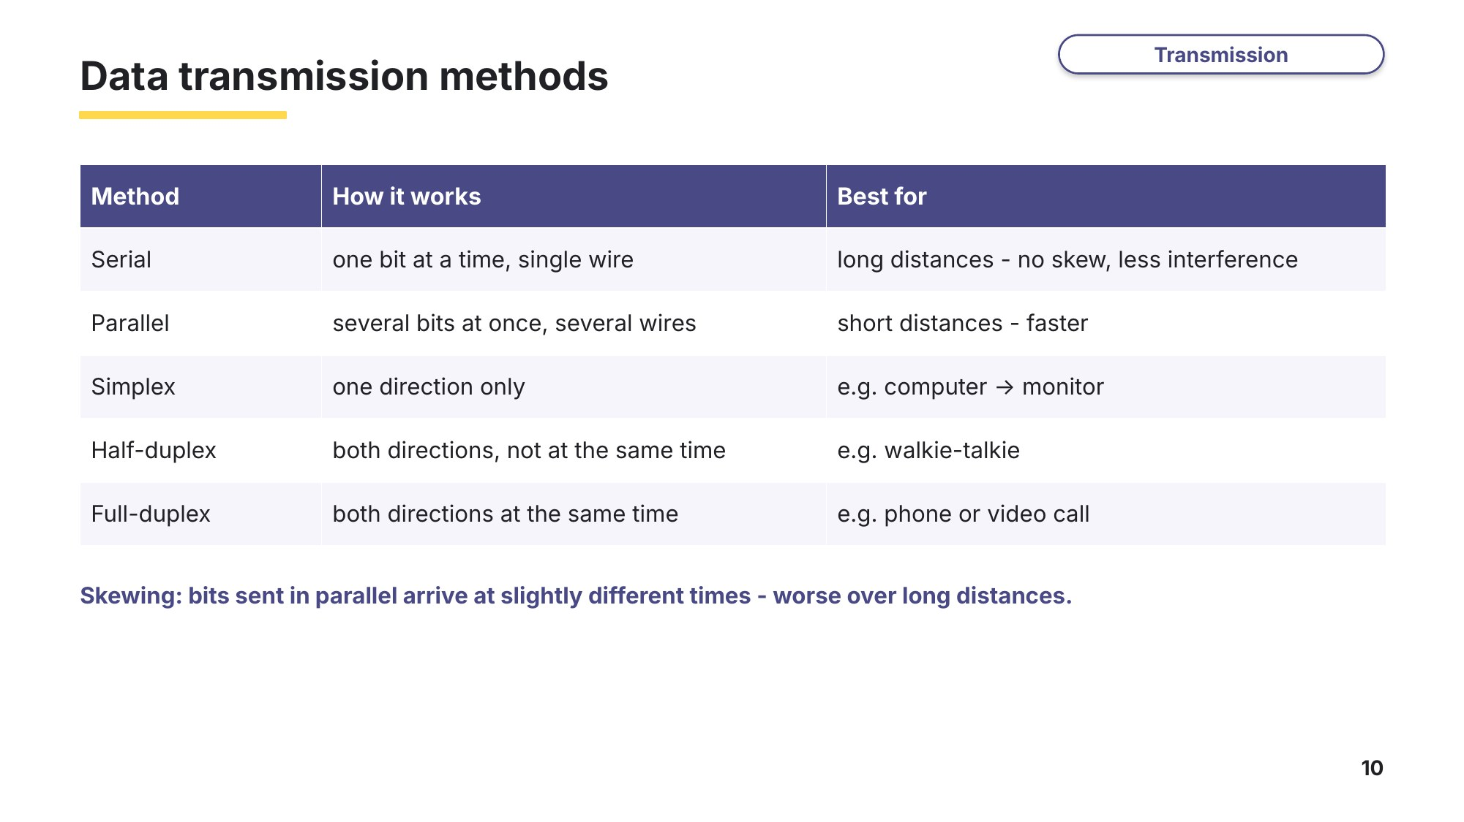
Slide 10 - Data transmission methods
Task 3 Data transmission and packets [21 marks]
3A Computer and printer
0478/11 October/November 2023 Q4
Data is transmitted between a computer and a printer.
(a) The data is transmitted one bit at a time down a single wire. The computer can transmit data to the printer and the printer can transmit data to the computer, using the same connection. Circle the two data transmission methods that will transmit data in this way. [2]
parallel full-duplex | parallel half-duplex | parallel simplex
serial full-duplex | serial half-duplex | serial simplex
(b) An odd parity check is used to detect errors in the data transmission. Explain how the odd parity check detects errors. [4]

(c) Another error detection method sends the data from the computer to the printer, then a copy of the data received is sent back from the printer to the computer. The two sets of data are compared to see if they match. State the name of this type of error detection method. [1]

3B Data packets
0478/11 May/June 2024 Q4
Data packets are transmitted across a network from one computer to another computer.
(a) Describe the structure of a data packet. [3]

(b) Packet switching is used to transmit the data packets across the network. Identify the device that controls which path is taken by each data packet. [1]

(c) Serial data transmission is used to transmit the data packets across the network. Explain why serial data transmission is used to transmit the data packets. [3]

3C Packet switching diagram
0478/13 May/June 2023 Q5
Complete and annotate the diagram to demonstrate how packet switching is used to transmit data across a network, including the use of routers, from Device A to Device B. [4]
Device A |  | Device B
3D Choosing a transmission method (exam-style)
For each use, identify whether simplex, half-duplex or full-duplex transmission is most suitable and give a reason. [3]
Use | Method | Reason
A keyboard sending key presses to a computer
Two walkie-talkie radios where only one person can talk at a time
A video call between two students
Learn Error detection
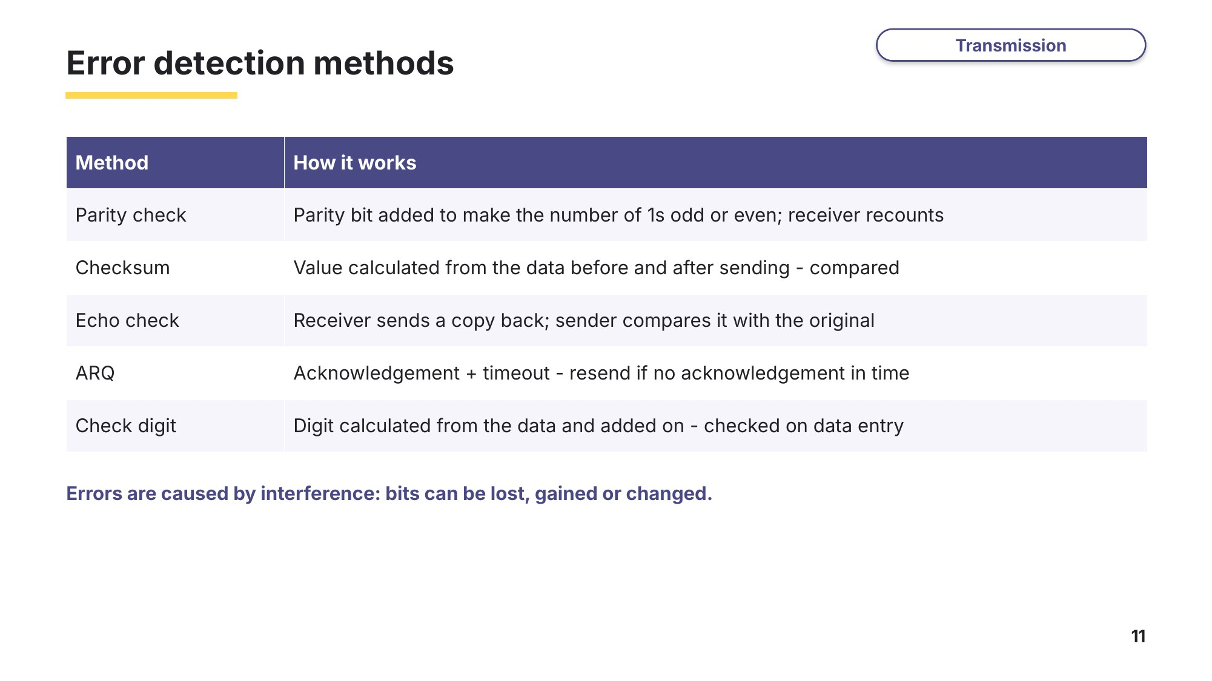
Slide 11 - Error detection methods
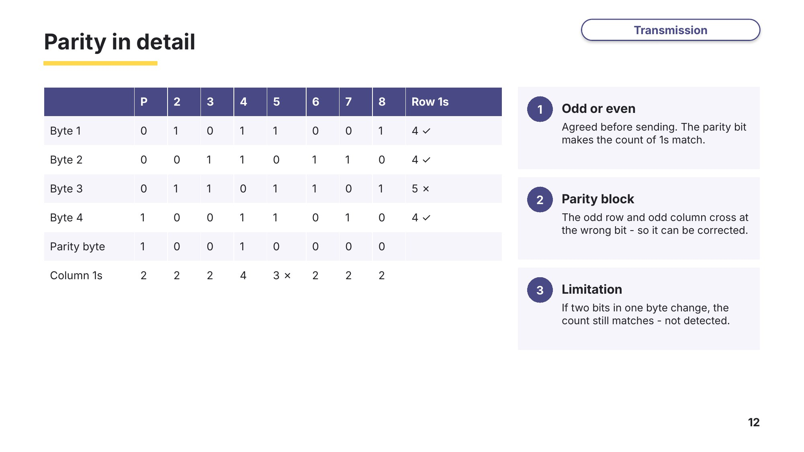
Slide 12 - Parity in detail
Task 4 Error detection [26 marks]
4A Naming the methods
0478/12 May/June 2024 Q6
The table contains statements about error detection methods. Complete the table by giving the correct error detection method for each statement. [5]
Error detection method | Statement
 | An odd or even process can be used.
 | A value is calculated from the data, using an algorithm. This happens before and after the data is transmitted.
 | A copy of the data is sent back to the sender by the receiver.
 | Acknowledgement and timeout are used.
 | A value is appended to data that has been calculated using the data. This value is checked on data entry.
4B Errors and ARQ
0478/13 October/November 2023 Q5
Errors can occur when data is transmitted.
(a) Give one reason an error may occur when data is transmitted. [1]

(b) Some error detection methods use a calculated value to check for errors. Tick (✓) one box to show which error detection method does not use a calculated value to check for errors. [1]
A | Check digit
B | Checksum
C | Echo check
D | Parity check
(c) An automatic repeat request (ARQ) can be used to make sure that data is received free of errors. It can use a positive or negative acknowledgement method to do this. Explain how an ARQ operates using a positive acknowledgement method. [5]

4C Completing the statements
0478/13 May/June 2025 Q7
Data is sent from an employee’s computer to a server. The data is correct when it is sent, but an error is detected when the data is received.
(a) Describe how an error can occur in the data during transmission. [2]

(b) Complete the statements about methods of error detection and correction. Use terms from the list. Not all terms need to be used. You should only use each term once. [8]
acknowledgement | automatic repeat query (ARQ) | binary | bit
byte | calculation | check digit | checksum
correct | echo check | error | even
incorrect | negative | number | odd
positive | timeout
A parity check is set to be ………………………… or ………………………… . A parity ………………………… is added to each byte before transmission to make it match the set parity.
An ………………………… involves comparing the data sent to the data received back from the receiving device.
An ………………………… uses acknowledgement and ………………………… . The acknowledgement system can be ………………………… or ………………………… .
4D Parity block (exam-style)
Four bytes are sent with a parity byte, using even parity. The first bit of each byte is the parity bit. This is the block that was received:
 | P | 2 | 3 | 4 | 5 | 6 | 7 | 8
Byte 1 | 0 | 1 | 0 | 1 | 1 | 0 | 0 | 1
Byte 2 | 0 | 0 | 1 | 1 | 0 | 1 | 1 | 0
Byte 3 | 0 | 1 | 1 | 0 | 1 | 1 | 0 | 1
Byte 4 | 1 | 0 | 0 | 1 | 1 | 0 | 1 | 0
Parity byte | 1 | 0 | 0 | 1 | 0 | 0 | 0 | 0
(a) Identify the byte and the bit that contain the error. Explain how you found it. [3]

(b) Explain why a parity check might not detect an error in a byte. [1]

Learn Encryption and exam technique
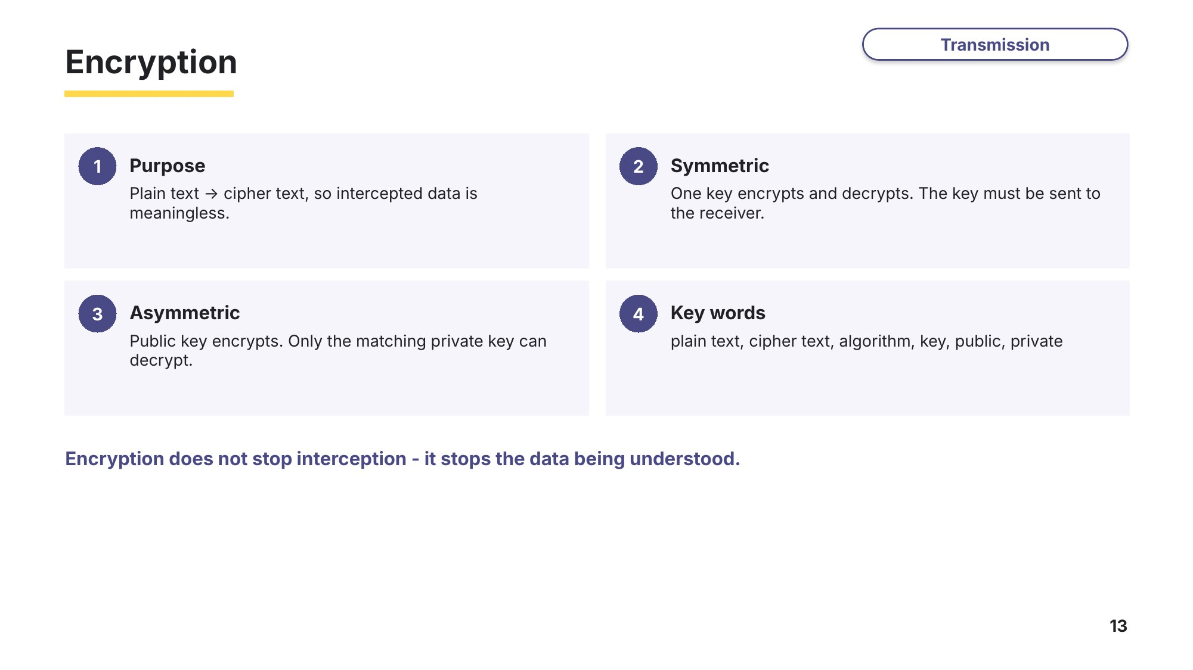
Slide 13 - Encryption
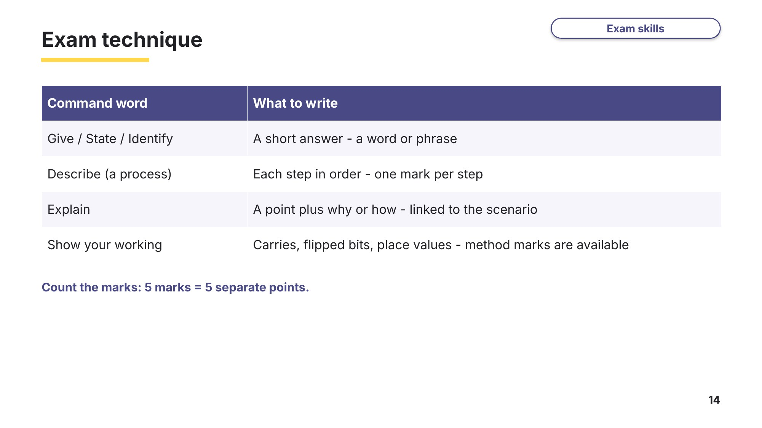
Slide 14 - Exam technique
Task 5 Extension: encryption and explaining processes [12 marks]
5A Symmetric encryption
0478/12 May/June 2024 Q2(c)
Data is often encrypted when it is transmitted from one device to another.
(a) Explain how data is encrypted using symmetric encryption. [4]

(b) Give the purpose of encryption. [1]

5B Checksum (exam-style)
A school sends exam results from its server to a parent’s computer. A checksum is used to check the data for errors.
Describe how the checksum is used to check the data for errors. [4]

5C Packets out of order (exam-style)
A video file is sent across the internet using packet switching. Explain why the packets may arrive out of order, and how the receiving computer puts the file back together. [3]

